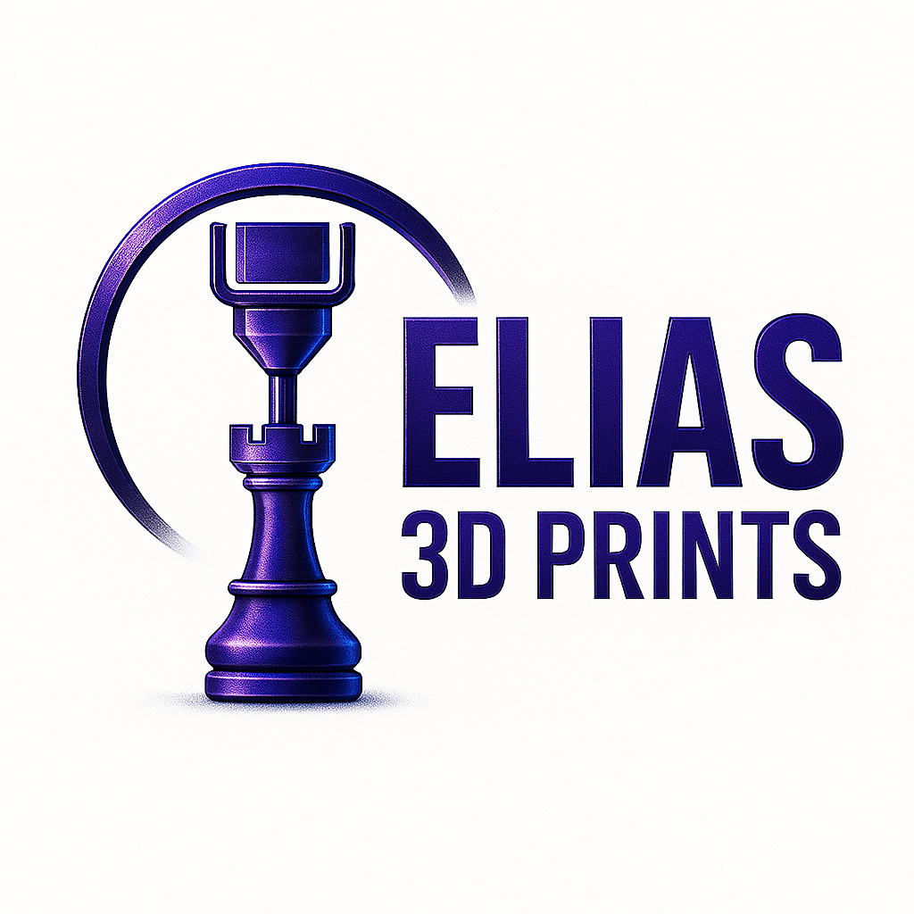
“Bringing Your Imagination to Life.”
Phone: 850-323-7713 | Email: elias.3d.prints@gmail.com | Tallahassee, FL

Services Offered
- Custom 3D Printing
Reverse Engineering
Prototyping
Cosplay Props
Replacement Parts

Pricing Overview
• Design & Engineering Fee (one-time): $85 flat
- Includes CAD modeling from photos or sample part
- Includes one prototype test print
• Final Print Cost (per piece): $8–$12
- Material: PETG or ASA (automotive-grade)
- Finish: Raw or sanded (optional paint extra)
• Optional Add-ons:
- Paint or clear coat: +$5 per piece
- Additional prototypes: +$10 each
NOTE:
- Typical turnaround: 2–7 business days
- Multi-material printing available
- Design/CAD fees start at $25+
- Complex reverse-engineering may require additional design time and cost; minimum $150.
- Bulk orders receive discounted print rates
- Rush service available if 3D model files are provided by customer.
Typical turnaround: 3–7 business days after receiving all reference materials and requested material to use.
Final Note: Design fee is non-refundable once modeling begins. Final parts are for visual and light-duty use unless otherwise specified.

